Methodic instructionsfor discipline “ Biotechnology of Agricultural plants”
Biotechnology daily, Master students

Seminar 1. Food security is one of major concerns for the growing global population Practical applications of plant tissue culture. Show the examples for the different plant species

Sem 2. The molecular biotechnology used for creation GMOs Practical applications of seed culture and embryo culture. Show the examples for the plant species.

Sem 3. Theme: Different breeding techniques and its requirement for improvement of agricultural plants Somatic Embryogenesis Major Steps of Tissue Culture.

Sem 4. Production of vitamins and biological active compounds by plants
Sem 5. GM crops as food and feed products. Methods of recombinant DNA and Fertilization in vitro. Haploid technology.
Sem. 6. The features of biochemistry and physiology of growth and metabolism of microorganisms in terms of practical agricultural biotechnology.
Sem. 7. Droplet digital PCR (ddPCR) technologies and SGS technologies to develop of GM crops. Strategies to increase agricultural production.
Sem 8. CRISPR-Based Genome Editing for Nutrient Enrichment s.
Sem 9. Combination of advances in functional genetics, proteomics and bioinformatics.
Sem 10. Characterization and use of different molecular markers for crops. DNA molecular markers in plant breeding: current status and recent advancements in genomic selection and genome editing.
Sem 11. Major advanced in development of agricultural plants with new symbiotic and antibiotic interactions between plants and microorganisms. Phytomicrobiome for promoting sustainable agriculture and food security: Opportunities, challenges, and solutions
Sem 12. The examples for creation of agricultural plants with new antagonistic interactions between plants and fungi, bacteria and insects.
Sem 13. The modern research for identification of genes responsible for the formation and activation of hormones in plants.
Sem 14. Development of Biofortified Crops Through CRISPR-Cas Genome Editing Approach.
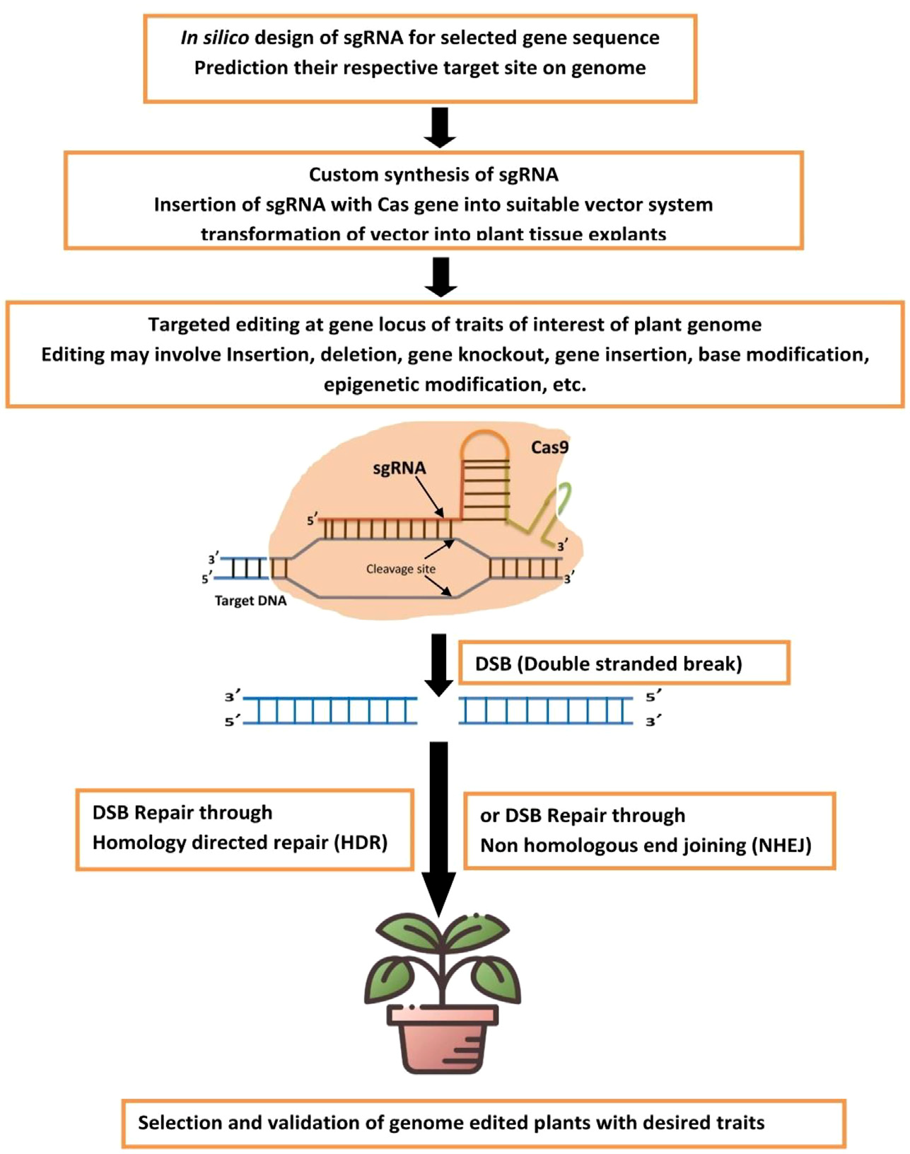
Schematic representation for CRISPR-Cas genome editing methodology for developing genetically edited biofortified plants.

Sem 15. The modern approaches of genetic engineering in plants biotechnology: constructing of genes for expressing in plant cells, selectable markers, methods of introducing the foreign DNAs into cells, identification of the foreign DNA in transformed cells and organisms, determination of the expression pattern of the foreign DNA and the direction for application to improve valuable traits.

